**“When It Rains It Pours”: Does It Rain More in Seattle or Pittsburgh?**

***Introduction:***

When people think of Seattle, they often think of rain. The movie Sleepless in Seattle even references this when Annie Reed's dad tells her, "It rains nine months of the year in Seattle". Having lived in Seattle for most of my life, this quote isn't entirely wrong. However, I also spent my undergraduate years living in Pittsburgh, and the city absolutely gets its fair share of rain, which is at least partially what inspires the title of this report. So, all of this got me thinking: "Does a city like Pittsburgh (that gets extreme rain but at possibly less of a frequency) get more rain than Seattle (where rain is more common but often considered not as aggressively)?"

***Data Collection:***

For this report, we decided to compare the rainfall in Seattle, WA, to the rainfall in Pittsburgh, PA, between the years of 2018-2022 (five-year period).

We collected this data from the US government's National Center for Environmental Information (NCEI), and we used the National Oceanic and Atmospheric Administration (NOAA) to collect our rainfall data using one data station for each city. For Seattle, we chose to use the First Hill neighborhood, located near Downtown Seattle. For Pittsburgh, we used Pittsburgh International Airport. Based on the sources that we used, we have good reason to assume that this data was collected with integrity and of high quality.

***Analysis & Methods:***

To test our initial question in this report, we calculated the mean monthly precipitation for both cities and determined if there was a significant difference between each month.

***Results:***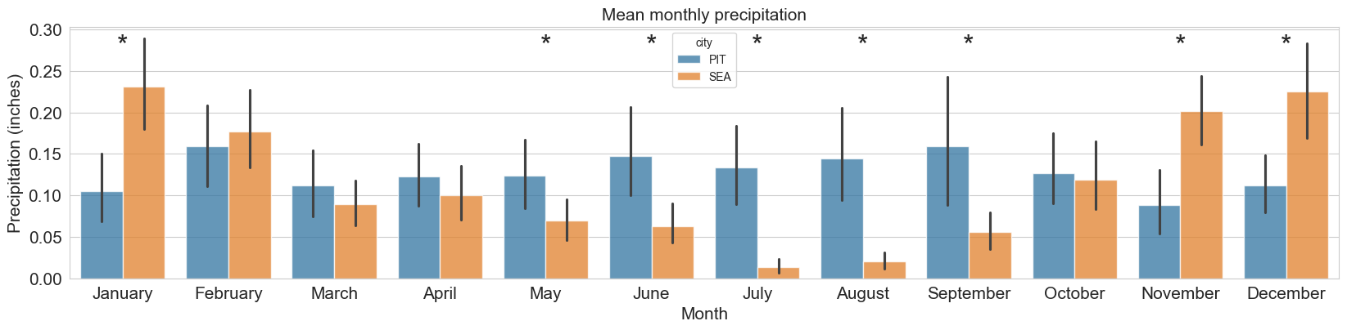

Mean monthly precipitation between Seattle and Pittsburgh. * indicates significant difference in rainfall.

Our results show some surprising results:

* For the months of February to April, Seattle and Pittsburgh were very evenly matched in rainfall. October also showed similar precipitation averages as well.
* However, Seattle had significantly more rainfall in the winter months (November-January), while Pittsburgh had significantly more rainfall in the late spring through early fall months (May-September).
* This data also shows that Seattle has very little rainfall on average in the summer months of July and August, while Pittsburgh has some of its peak average rainfall in June, August, and September.
* Seattle also had the top four highest mean monthly precipitation in November-February.
* In contrast, Pittsburgh had two months that exceeded 0.15 inches of average precipitation and never exceeded 0.2 inches of mean monthly rain.

Conclusion:

Based on the results, Seattle experiences significantly more rainfall in November, December, and January, while Pittsburgh experiences significantly more rainfall from May through September. This data also holds the best-kept secret of Seattle, that the summer months of July and August have very little rainfall. Although it still might rain nine months of the year in Seattle, if you've been considering paying a visit to the Emerald City, consider visiting during the summer months!